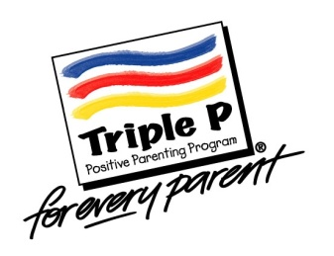
Online program to help families of children with eczema

Every day, thousands of Australian children suffer the effects of eczema, and families struggle with managing eczema and children’s behavioural and emotional adjustment.
Healthy Living Triple P is an adaptation of the successful Triple P - Positive Parenting Program, offering practical ideas and support for parents of children with eczema. This innovative online program is designed to help parents manage their child’s eczema more easily, help children cope with their eczema and emotions, prevent and manage difficult child behaviour, and reduce the impact of eczema on families.
Over the next few months, parents of 2-10 year old children with eczema are able to access Healthy Living Triple P free of charge as part of a research project through the Queensland Children’s Hospital, Griffith University, and the University of Queensland. For more information, please visit us at https://exp.psy.uq.edu.au/eczema/, contact Dr Amy Mitchell on (07) 3735 6462, or email healthyliving@uq.edu.au.

